Official league roster - Soccer
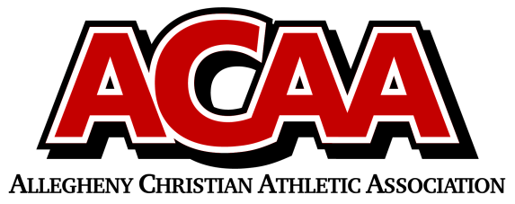

School Name: Blair County Christian
Team Colors: Green and White
Overall Wins ___ Losses ____ Ties ___
ACAA Wins ___ Losses ____ Ties ___ OPPONENT: __________________________
Date: _________
Number | Name | Year | Position | Homeschool
15 | Seth Nicodemus | 12 | STR
2 | Dalton Snyder | 12 | Def
22 | Brad Maretich | 11 | Def
7 | Caleb Hileman | 10 | Mid
16 | Jon Marucci | 10 | Def
19 | Malachi Teis | 10 | Def | Yes
12 | Donovan Bickings | 9 | Mid
3 | Silas Marucci | 9 | Mid
21 | Sayge O’Donnell | 9 | Goalie/Mid
25 | Blake Grissinger | 8 | Str | yes
17 | Aaron Love | 8 | Mid
14 | Titus Teis | 8 | Goalie/Mid | Yes
23 | Devon Hewitt | 7 | Def
11 | Donovan Marucci | 7 | Mid
20 | Samuel Platt | 7 | Def
4 | Donny Shepherd | 7 | Mid
8 | Hayden Snyder | 7 | Mid

Head Coach: Sean Teis
Asst. coach: Kevin Bickings
Asst. coach: Dusty Huston

Official ACAA League Team Roster. to be submitted to the scorer’s table before each game.

